Project planning document

## Introduction

The topic of the proposed project is to create a competitive multiplayer mobile game that relies on real world fitness activity to gain an advantage within the game world. The idea is based around the success of mobile fitness applications that have been able to take advantage of improvements and wide scale adoption of health tracking technology and the success of so called freemium games, these are games that are free to play but offer a large in game advantage to players that are willing to spend money on their account. With the switch to in game rewards being given for fitness activity instead of financial. Implications of the project are two-fold; the project has the scope to be able to both fill a gap in the market as currently no other application works in the same way, and to act as a research tool to test whether an application with this kind of incentive could be used to encourage users to undertake more fitness based activities.

## Aims and objectives

### Project aim

To create a mobile based multiplayer game that gives the player character an in-game advantage determined by fitness data captured through their mobile device.

### Project objectives

To fully justify the project, research must be conducted into the state of the current art, a gap in the market must be clearly defined to proceed with project development. A clear competition analysis will be complete by **29/12/2016.**

If the project is deemed justified research will be conducted in several areas, these being;

* The psychology behind fitness, specifically the reasons behind why some individuals take part in exercise and why others do not, what methods can be used to encourage a user who do not regularly exercise to do so
* The reasons why the most popular mobile fitness applications are at the top of the market, what makes them successful, what do they do that others do not
* Analysis of competition in games and fitness and whether common aspects of the two can be used to improve the proposed application
* The reasons behind the success of certain types of computer games, specifically what makes them successful, what genre they fall into and would they work as a mobile application
* Analysis of multiplayer games and what makes certain types successful and others not.
* The reasons behind why the most popular mobile games are popular, with considerations made to the genre, accessibility and overall aesthetic design of the game.
* Programming tools and game engines must be researched to determine the most appropriate for the development of the application
* Open source API’s should be researched to determine which are the most popular and prevalent and to determine which API or API’s will be most suitable for the development of the project

The findings from the gathered research must then be used as a tool to help develop the application, the research portfolio must be completed by **16/02/2016**.

To finalise the project direction a prototype of the application must be created quickly to allow for any changes in project goals, the most likely change in project goal would be a shift into a project focused fully on the research aspect of whether an application of this mature would be more likely to motivate a user to take part in regular fitness activities. With this in mind a prototype should be developed by **01/01/2016**.

Based on the prototype created usability testing should be undertaken, feedback from this usability testing should be used to improve upon the prototype of the application, this process should occur multiple times over the course of the applications development with the first round of usability being completed by **14/01/2016**.

A mobile application must be created that fills the following criteria;

* The application must be a game based around the findings of previously conducted research
* The application must offer an in-game reward for the user completing real world fitness activities
* The application should be developed to run on a mobile operating system to allow for ease of access and play
* The application must make use of fitness data taken from sensors on the user’s mobile device or through the use of open source API’s in order to determine the correct level of in game reward that should be given to the player
* The system should be designed to operate online; this is to allow for easier interaction between the active player base.
* The application should be designed to be played competitively, this is to increase player engagement and to get the most physical benefit from the application
* The application must have undergone a series of user ability tests, feedback from these tests should improve upon the original design

Should these requirements be met the application will be considered complete as far as the scope of this project is concerned, development on the application should be completed by **25/03/2016**.

## Milestones, main tasks and deliverables

## Project scope

The scope of the project is to create a mobile game that makes use of fitness data gathered from health tracking hardware and software located on the user’s mobile device to grant an advantage to the users in game account. The application will be designed operate in a multiplayer setting, with actions of the player potentially having repercussions on other users operating on the game server, this step is designed to improve the social interaction of the game and add an element of competition with the overall goal being a general improvement in engagement of the game.

### Out of scope

Whilst the main goal of the proposed application is wide consumer adoption this is an unlikely outcome when considered in the scope of the project. It is unlikely the application will be made available across multiple platforms although this can be determined by development choice, and it is also an unfeasible goal to state the application will be made available on various application stores such as though available on Android and IOS, this is due to a lack of knowledge on the rules surrounding submission to these application repos and the lack of time available within the project scope to gain the knowledge.

High quality art work is also considered out of scope for this project, unless suitable open source or free use textures and sprites are found online, the lack of experience in this area would require too much time to bring up to a suitable standard.

## Milestones & Main tasks

The following objects represent milestones and main tasks in the final year project, milestones are considered as such in the Gantt chart below with main tasks being made up of several sub tasks in the Gantt chart.

### Project Milestones

* Review point 1 & Review point 2 completion
* Completed final year project report
* Application prototype
* Completed application
* Project hand in

### Project main tasks

* Project Planning Document
* Competition analysis
* Research portfolio
* Usability testing

## Sources of information, resources required

### Resources

**Mobile device with activity tracking hardware or software** – Required to monitor the player’s activity whilst not playing the game the data gathered from this tool is then used to produce the players in game reward.

**A TBD software development kit –** A SDKwill be required to develop the application, based on the findings of the research portfolio an SDK will be selected that best meets the needs of the project.

**Test group –** A test group is required to give feedback on the application, findings from usability tests conducted with the test group will be used to inform on future iterations of the application.

**Web server –** A web server is required to allow for multiplayer activity.

**Database –** Some database will be required to store the players account details and their game progress.

**Development machine –** To produce the application a development machine is required

**Art assets –** As the focus of the project is application development and possible research implications, open source art assets availableonline will be used to implement the visual aspects of the game.

### Sources of information

**Research papers & Books** – Peer reviewed work and published literature will make up the bulk of the background research in this project, this is to maximise the validity of the information used. With the subject matter covered in the project (fitness and gaming) there should be no shortage of books and papers covering these topics.

**Online articles** – To get the most up to date information on player numbers and financial statistics the use of online articles will be crucial, however considerations must be made about the validity of information found online, to overcome this any sources found online will be verified before they are incorporated into the project.

## Project risks

|  |  |  |  |  |  |  |
| --- | --- | --- | --- | --- | --- | --- |
| Risk ID | Risk event description and impact area | Impact rating | Probability rating | Risk score | Risk response description | Trigger |
| Software failure | Software does not function on personal computer | Low | Low | 4 | Attempt to reinstall faulty software, should this fail to fix the problem, work on working computers such as PC’s available on campus | Software error |
| Hardware failure | Development machine is effected by hardware failure stopping work being completed | Low | Low | 4 | Repair broken hardware, whilst this is going on, work on computers provided by the university | Hardware error |
| Networking failure | Networking failure means work cannot be uploaded to the NOW dropbox | High | Low | 2 | Move to a location that has an active network connection, if this is a problem with the universities network hand in a hard copy of the project and contact the university directly for instructions on how to proceed | Hardware error |
| Miss deadline (project imposed) | A project set deadline is missed, throwing time management out of order | Low | High | 3 | Rework the schedule so the incomplete work will still be finished on time for the final hand in | User error |
| Miss deadline (course imposed) | A specific hand in deadline is missed for example handing in a copy of the CMAP | High | Low | 2 | Hand in complete project as soon as possible, follow time schedule closely to reduce the risk of this | User error |
| Scheduling conflict | Other modules take time away from project | Low | High | 3 | Plan work ahead of time to avoid a scheduling risk | User error |
| Lack of experience | Having little experience with software used in project leads to delays in development or poor final product | High | Low | 2 | Start work early to allow for compensations in lack of experience, spend time getting up to speed with software intended for development | User member |
| Loss of data | Specific pieces of project are lost | High | Low | 2 | Create regular backups of any work that is worked on in multiple locations, use source control for development of application | Hardware error |
| Lack of testing | Not enough usability testing is conducted on the application | High | High | 1 | Manage time to allow for sufficient testing, speak to project sponsor if this appears to be a problem | User error |
| Small testing group | Too small a testing group leads to a lack of validity in data | High | High | 1 | Speak with project sponsor | User error |

## Professional, social, ethical and legal issues

### Professional

Within the scope of the project, there are no foreseeable professional issues that require consideration, because of this the project will have a low professional impact.

### Social

The proposed application is an attempt to improve the fitness and lifestyle of its user base, this beneficial social impact needs to be at the forefront of development and be promoted to the users of the system, for this reason the project will have a high social impact.

### Ethical

As with professional issues within the current scope of the project there are no predicted ethical issues related to this project, meaning the ethical impact of this project is low.

### Legal

Depending on the implementation of the application some user data may need to be stored, this requires the project follow laws surrounding data protection. The primary law in the UK for dealing with data protection is the Data Protection act 1998, which states a user’s data must only be used for “limited and specifically stated purposes” and “kept for no longer than is absolutely necessary” (Data protection, 2016). As the legal implications for mishandling a user’s personal data are so high, the legal impact of this project is considered high, to minimise the potential risk the Data Protection act must be studied and adhered to always during the project.

## Gantt chart

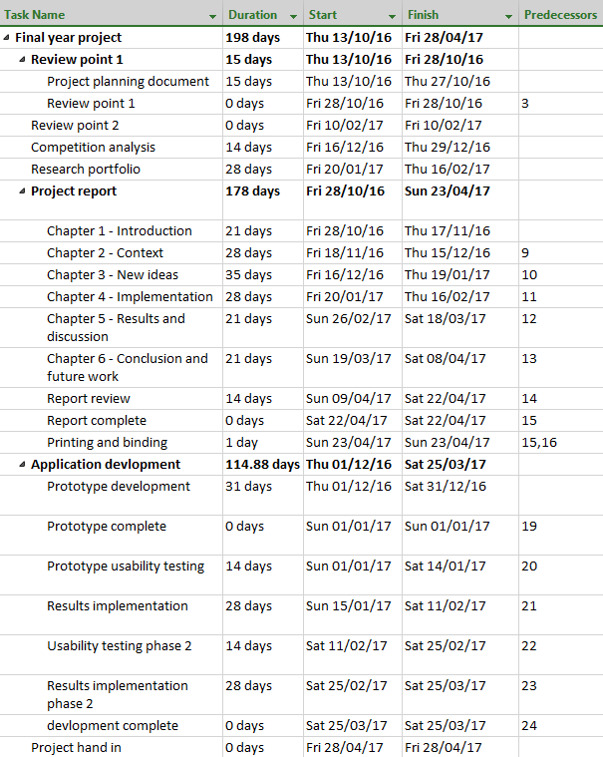

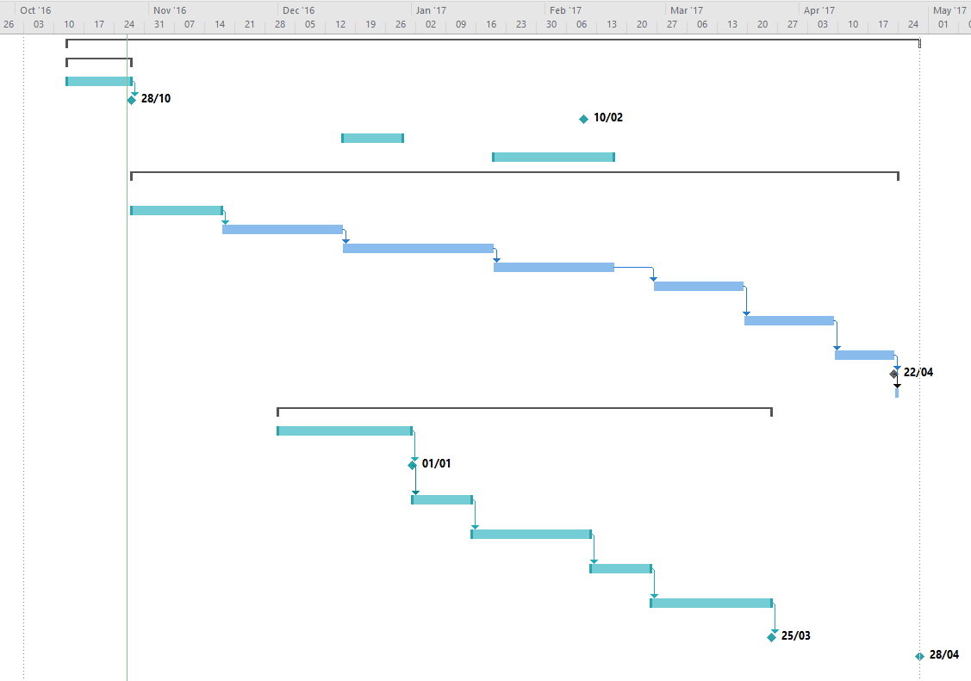

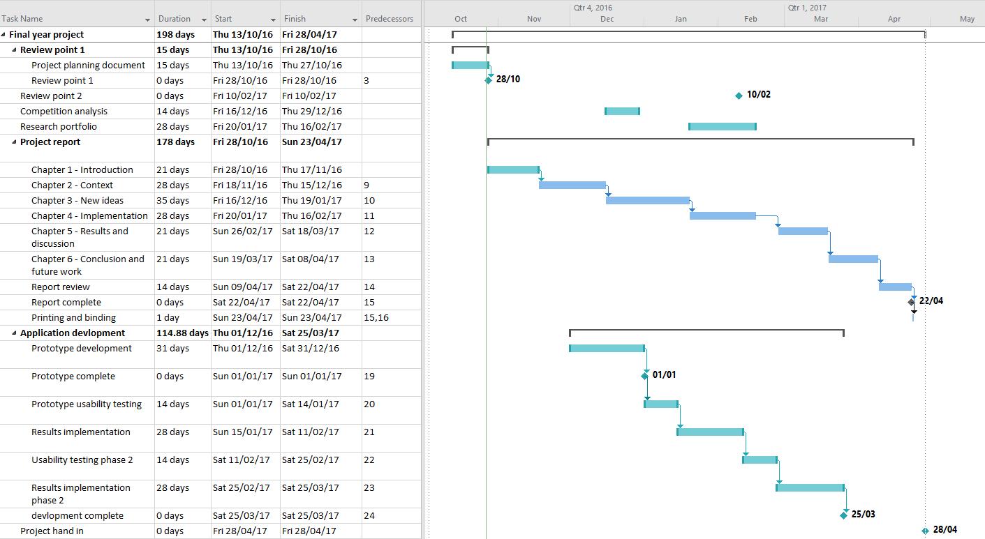

## References

Data protection act1998, c. Available at: http://www.legislation.gov.uk/ukpga/1998/29/contents (Accessed: 24 October 2016).

Data protection (2016) Available at: https://www.gov.uk/data-protection/the-data-protection-act (Accessed: 24 October 2016).